REPORT ON STAKEHOLDER ENGAGEMENT WITH MUNICIPAL AND DISTRICT ASSEMBLIES ON DISBURSEMENT OF CARBON PAYMENTS UNDER THE GHANA COCOA FOREST REDD+ PROGRAMME

13TH JUNE 2023
KUMASI

Introduction

In January 2023, Ghana received her first Carbon Payments under Ghana’s Premiere REDD+ Program, dubbed the ‘Ghana Cocoa Forest REDD+ Programme (GCFRP)’, from the World Bank. The Program has adapted the Community Resource Management Area (CREMA) Model and developed community governance structures for the implementation of the Program. The community governance structure is called Hotspot Intervention Area, which aggregates relevant Political Districts.
In line with the Ghana REDD+ Strategy and Benefit Sharing Plan, for disbursing the Carbon Payments under the Program, The Chief Executive of the Forestry Commission organized a stakeholder engagement organized with, Municipal and District Assemblies, within Hotspot Intervention Areas (HIAs). The meeting took place on 13th June, 2023 at the Golden Bean Hotel in Kumasi.
The objectives of the engagement were as follows:
- Discussion on the roles and responsibilities of MMDAs
- Modalities for disbursing the Carbon Payments to the MMDAs

Participation and Institutional Representation
The Participants included the Chief Executive of the Forestry Commission, the Directors; Climate Change Directorate, Resource Management Support Center, Forestry Commission Training Center, Managers from the Forestry Commission and Cocobod, Municipal and District Chief Executives, and Planning Officers from the Implementing Assemblies. The Participant list is attached as appendix I.

Welcome Address
The Director for the Resource Management Support Center (RMSC) gave welcomed all participants and expressed his gratitude for the support of the various Assemblies during the just-ended Green Ghana Day. He, therefore, pleaded with the participants to fully engage and let the meeting be more interactive.

Opening Statements by the Director, Climate Change Directorate
Mad. Roselyn Adjei, welcomed all participants and expressed her gratitude for the impressive turn-up. According to her, the workshop formed part of the key processes that would enable the disbursement of carbon funds to the local government structures within the Hotspot Intervention Areas. She said the GCFRP programme was results based, which was also a collaborative programme between the Forestry Commission and Ghana Cocoa Board. She added that the success of Climate Change was the reduction in carbon emissions which transforms into carbon credit and this had a market in our international space. She reiterated that Ghana has recorded its first validated and verified emission reductions and has sold its first generating credit-generating a results-based carbon payment for the period between June- December 2019.

In having to come to this carbon payments made, a benefit sharing mechanism has been developed to effectively distribute carbon and non-carbon benefits and therefore the need for implementing MMDAs to be aware of the progress of work in relation to the programme.

Statement by the Chief Executive, Forestry Commission
Mr. John Allotey, Chief Executive of the FC said the GCFRP was a collaboration programme between the FC and COCOBOD which started in 2019 and will be for a period of Six(6) years. The President of the Country launched the Programme. The aim was to secure the future of the forests and make the cocoa sector climate-resilient, whilst sustaining and enhancing income and livelihood opportunities for farmers and forest users in all the Hotspot Intervention Areas. He said the programme is results-based and therefore the onus lies on local authorities to put in much to be able to achieve the goal of the programme. He added that the FC and COCOBOD are planting trees within the Cocoa farms and maintaining trees both in the Cocoa farms and outside of it. Once the trees are well developed, carbon emission would be measured and verified and based on the difference funds would be acquired. The more the environment is protected, the more ER and the more carbon credit the government receives. An amount of USD50 million has been earmarked for the implementation of the programme and much work needs to be done to utilize the funds. The payment for the second half (June- December) 2019 has been received an amount of USD4.8million out of a total amount USD50million that the World Bank has made available.
The funds received needed to be disbursed to the programme's various beneficiaries in line with the GCFRP Benefit Sharing Plan. The various beneficiaries include the farmers, communities, traditional authorities and the Government (FC, COCOBOD and MMDAs) and a percentage of the funds has been assigned to each beneficiary. He added that, within the districts there are Hotspot Intervention Areas, and there was the need to know the farmers, Traditional authorities and HIA Management Boards Executives and how they will be utilizing the funds allocated to them; therefore, the Political leaders should take up those responsibilities to help monitor the utilization of the funds. He added that the GCFRP is the first of the five (5) programmes on Emission Reductions being implemented in Ghana and mainly implemented in high cocoa growing areas within the country.

The purpose of the meeting was to make stakeholders aware of the funds that had been received. He emphasized that the key role of the stakeholders from the MMDAs was advocacy on the programme for communities to be aware and handle safeguard-related issues. This will help them fight against the major drivers of deforestation, mainly illegal mining, logging and fire outbreaks.

He added that, the 2020 emission reductions measurement process was yet to commence and will go through another measurement and validation process. Therefore, sensitization and education have to go down to the indigenes to help curb deforestation and also understand the effects of destroying the forest.
He concluded that all political leaders within the districts must get it right and take the lead to help make the programme a success as this will go a long way to improve the local economy since what we do within the district with regards to our forest matters.

KEY MESSAGES FROM THE CHIEF EXECUTIVE
- MMDAs must know the respective carbon funds due them, and the Fund Flow mechanism that must be followed in drawing down such funds.
- MMDAs are expected to champion advocacy about the emission reduction programme at the landscape level to help create visibility about the benefits of the programme as well as the drivers of deforestation and forest degradation.
- The President of Ghana expects proponents to be able to draw all carbon funds (thus USD 50 million) and that the Chief executive admonished the MMDAs to demonstrate interest for the programme, and be concerned about supporting the proponents on addressing the drivers of deforestation including illegal logging, illegal mining and fire.
- The carbon funds are expected to improve the local economy of the farmers and the local communities given that 69% of the funds are cut out for them.
- The activities we do in our forests matter; they impact on carbon emissions.
- The carbon funds to the MMDAs are only to complement the work of the MMDAs.
- It has been the initiative of the Commission to create a common platform that would foster exchanges, learning opportunities as well as sharing of lessons/experiences.

PRESENTATION ON THE GHANA EMISSION REDUCTIONS PROGRAMME AND BENEFIT SHARING PLAN
Mr. Thomas Gyambrah from the NRS led a presentation (Copy attached as annex I) on the Ghana Emission Reductions Programme and the benefit Sharing Plan. Participants were taken through the goal of the programmme and the fact that the GCFRP has carbon emission reduction potential of 10 m tCO2e for the first 6 years and 294m tCO2e over 20 years. Also the expected ER payment of $50m at $5 per ton of carbon based on performance. He said The GCFRP has recorded its first validated and verified emission reductions, with a value of 972,465 tonnes of carbon dioxide equivalent, generating a results-based carbon payment of USD 4,862,280.

In summary, the presentation of focused on the following:
- The Pillars under the GCFRP
- The overview and the rationale to the creation of the programme
- Participants were taken through the programme area (Map of programme area)
- The availability of a benefit-sharing plan that is intended to distribute carbon and non-carbon benefits effectively
- The importance of the benefit sharing plan detailing the beneficiaries (Farmers, Traditional authorities, Communities, Private Sector and the Government including Forestry Commission, COCOBOD and MMDAs), their roles and responsibilities and the modalities for sharing of the benefits
- The design process which was based on a wider stakeholder’s consultations and focus group discussions
- Who qualifies to be a farmer beneficiary and what makes them important
- The types of benefits are the Carbon and non-carbon benefits which in both ways could be financial or in kind. Also detailing their description of benefit and source of benefits
- The percentage of the funds allocated to the various beneficiaries
- The distribution of the first ER payment of a net of $3,538,779
- The ER payments to MMDAs according to HIAs
- The Fund Flow and Governance arrangements under the Ghana Cocoa Forest REDD+ Programme;
- The role of the HIA Implementation Committee, HIA Management Board (HMB) and the Consortium Partner(s)
- The roles and responsibilities of farmers
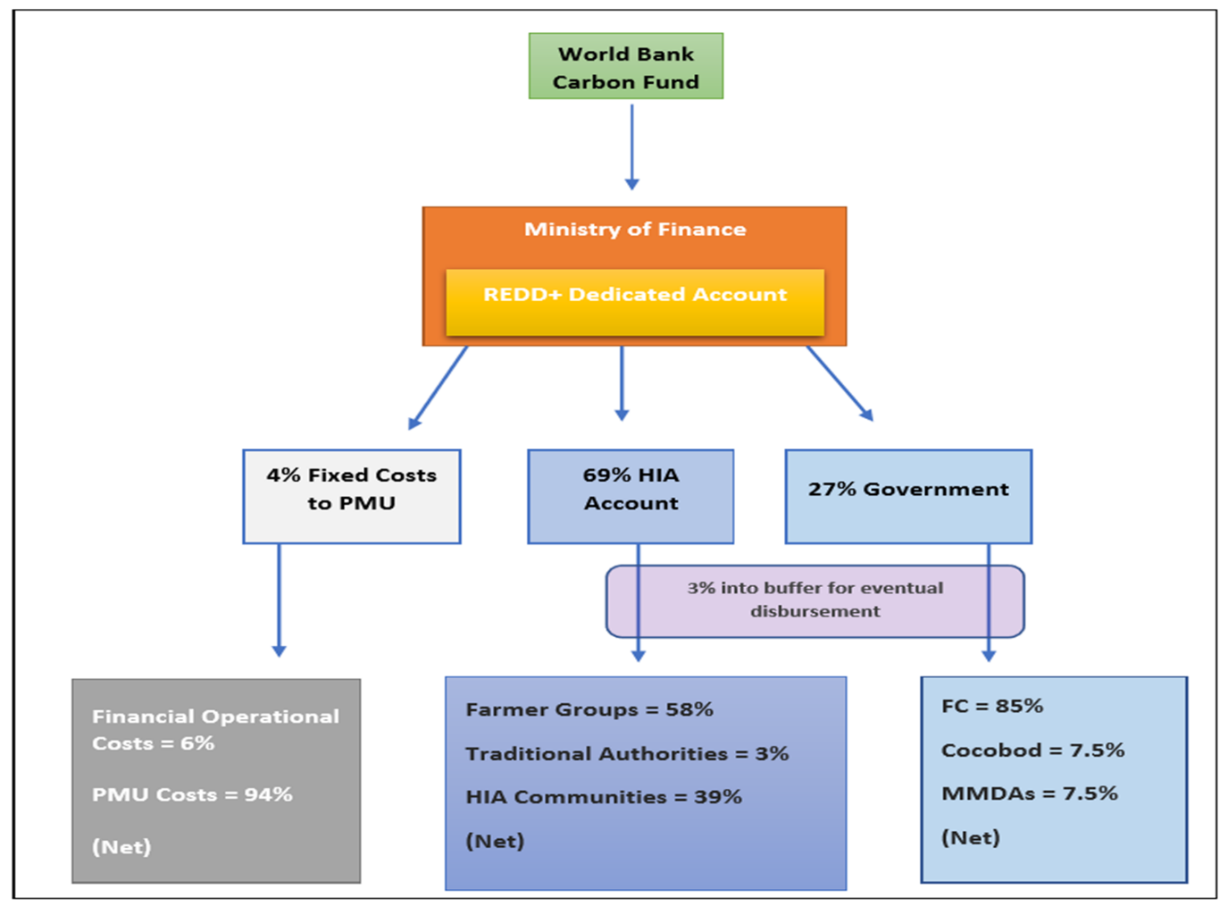
Figure 1 Disbursement modalities in the BSP

Q & A ON THE PRESENTATION
Question | Response
Why are the social performance indicators so low within Sefwi Wiawso? | The Funds received now was for the second half of 2019 (June to December) for which period the HIA in question did not have all the structures in place.  That notwithstanding most of the structures within the various HIAs are now in place. Additionally, the HIA functional units (representatives of the local communities) have been engaged and understand the processes. All the information is uploaded on online for all to access.
The implementation of community benefits was silent in the presentation, why? | One of the expected roles of the Assemblies in relation to the implementation of the community benefit is to ensure that it is implemented is in line with the Medium-Term Development Plan. This notwithstanding, the proponents are being systematic in the approach in terms of the benefit sharing implementation. However, the focus is to get the farmer and MMDAs benefits out of the way afterwards the community benefit will be next.
The Kisri Forest Reserve degraded, how do we rehabilitate it through the Ghana Cocoa Forest RDD+ Programme? | The Forestry Commission acknowledges that about 120 admitted farms in forest reservation at the time of reservation. The trend has however changed given that most of such farms have been extended. Forestry Commission is working with key partners including the designate Traditional Authorities to address this issue.  In part, the Ghana Cocoa Board of their flagship programmes dubbed Cocoa Management System (CMS) is taking the data of all farmers. This will help to identify the livelihood needs of farmers that should be supported. Again COCOBOD through the EU due Diligence has started work on decoupling cocoa production from forest reserve.
Illegal farming and mining are on the ascendency though there has been much education on its negative effects to the environment | The Political leaders at the local level should help in the fight against the menace since development starts at the local level.
Are the MMDAs to receive the community benefit funds on behalf of communities? | No, the funds will be received by the HMBs on behalf of communities. However, the MMDAs are expected to guide the implementation of the community benefit.
Are MMDAs receiving their allocations of the carbon funds in dollars? | No, all funds will be transacted in Ghana cedis.
Are there any guidelines for the utilization of funds? | Yes, as part of the programme key guiding documents such the Benefit Sharing Plan and the Fund Flow Mechanism Operational Manual have been developed.

Key Lessons
- This heightened awareness on BSP processes to wider stakeholder group.
- Greater appreciation of the GCFRP and the need to curb deforestation and forest degradation.
- Roles of MMDAs clearly defined

RECOMMENDATIONS
The meeting settled on the following key next steps:
- The date for the ceremony to present cheques to the HIAs and the MMDAs would be communicated soon.
- Participants were informed that WhatsApp platforms would be created for the various MMDAs to enhance communication
- Development and submission of work plans to undertake HIA specific activities by the MMDAs

CONCLUSION
The MMDAs agreed to the disbursement amounts as explained in the presentation and therefore gave the go-ahead for the cheques to be written to the district assemblies

